Tenda W6-S – Tools

- Click on “Tools” to upgrade the firmware version.

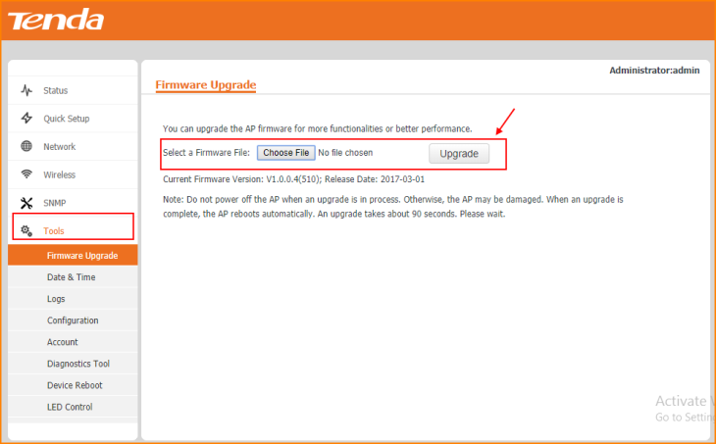

Note: Remember to “Save” the configuration.

- Click on “Tools” to check the System Time and edit the Sync details.

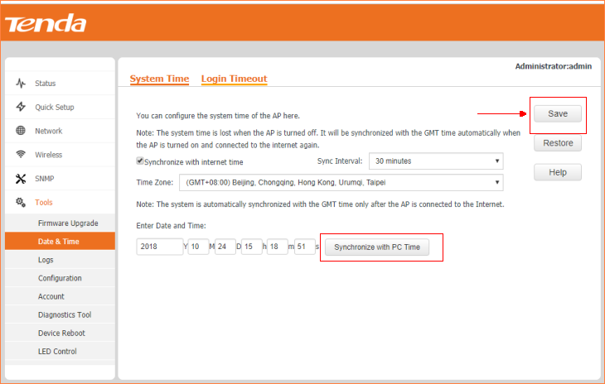

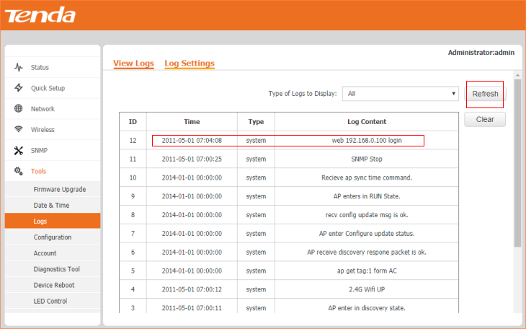

- Click on “Tools” and click “Configuration” to Backup and Restore the data.

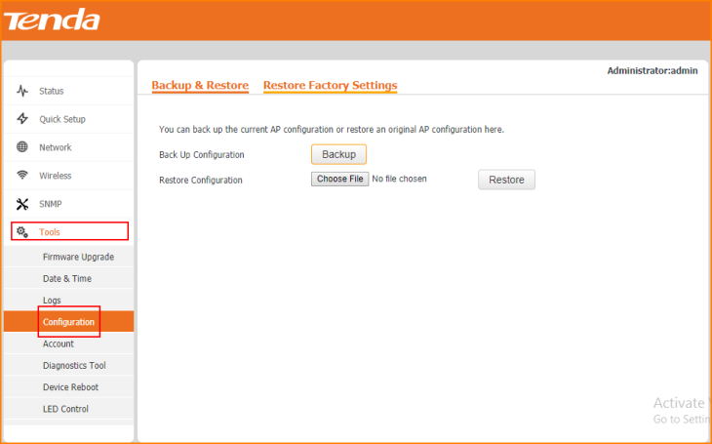

- Click on “Tools” and click “Account” to modify the Name & Password of login page.

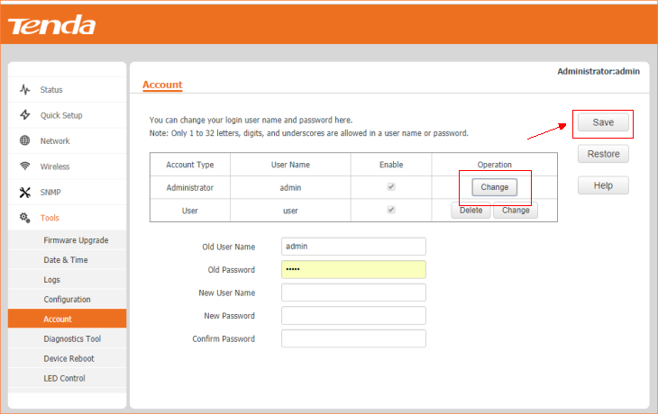

Note: Remember to “Save” the configuration.

- Click on “Tools” and click “Device Reboot” to reboot the W6-S from interface.

